***Team Indigo***

***Team Directory Dataset: Indiana Census Data***

|  |  |  |  |
| --- | --- | --- | --- |
| Name | Team Leader | Phone | Email |
| Ria Rajan | Week 12 – 11/08/21  Week 15 – 11/29/21 | 425-628-5780 | [Rajan17@purdue.edu](mailto:Rajan17@purdue.edu) |
| Trami Nguyen | Week 11 – 11/01/21 | 574-202-4535 | [tpnguyen@purdue.edu](mailto:tpnguyen@purdue.edu) |
| Brooke Miller | Week 14 – 11/22/21  Week 16 – 12/06/21 | 317-703-0559 | [Mill2887@purdue.edu](mailto:Mill2887@purdue.edu) |
| Dajanae Brangman | Week 13 – 11/15/21 | 317-480-0633 | [Dbrangma@purdue.edu](mailto:Dbrangma@purdue.edu) |
|  |  |  |  |

* Team Leader: Leadership in the group rotates. Each member should indicate the start date of the week they will serve as leader of the group. Leadership will follow the cycle listed.

***Meeting Schedule***

*Starting 11/01/2021, our team will meet at a frequency of twice per week until the completion of the project. Edit the table below accordingly.*

|  |  |  |
| --- | --- | --- |
| Meeting Dates | Meeting Times | Method of Communication |
| Tuesdays | 11:30 – 1:00PM | Text/Chat/Discussion Meeting |
| Thursdays | 11:30 – 1:00PM | Face-to-Face Meeting |

***Team Rules and Expectations***

1. Our project’s success depends on the contributions, commitment and best efforts of all team members; therefore everyone must actively participate to achieve their respective interdisciplinary activities.
2. We must all come to a consensus when making decisions about the project at hand. As a team we are to:
   1. Look at each situation individually
   2. Obtain input from all team members
   3. Communicate our understanding of all information
   4. Make the best decision based on the information presented

In the event that we cannot all agree or come to a consensus, then we will go by the majority rule vote.

1. Each individual is responsible for communicating with the team if any issues arise that may interfere with the completion of their assigned tasks or there is a difficulty attending any one of the meetings.
2. Each team members must maintain their contact information current. If there are any changes, the team must be informed of those changes as soon as possible.
3. All team members are responsible to follow-up and provide updates on the assigned task.
4. All project team members confront issues directly and promptly.
5. The Team Leader will document each team member’s contributions to the project and submit all weekly summaries and final project report to Professor.
6. We are all responsible for holding each other accountable. If any team member does not adhere to the rules and expectations set forth, individuals have every right to contact the Professor to state their concerns or discuss those openly with the team.
7. Any changes to the project baseline must be communicated with the team first and everyone must come to an agreement of the changes

***Code of Ethics***

1. We are to treat each other with respect and dignity.
2. We will be open to new ideas and information for the benefit of the project objective.
3. We will give each other an equal opportunity to voice opinions and contributions.
4. We will be honest and truthful in the information we present.
5. We will adhere to commitment to complete each assigned task set forth as part of the group project.

***Level of Commitment***

**Each team member must indicate his/her level of commitment to the project.** In the table below, replace the sample data with your name in the Name column and indicate how much time you intend to commit to the project in the Time (weekly) column.

|  |  |
| --- | --- |
| Name | Time (weekly) |
| Ria Rajan | 4-5 |
| Trami Nguyen | 4-5 |
| Brooke Miller | 4-5 |
| Dajanae Brangman | 4-5 |
|  |  |

***Type each team member’s name in the list below.***

***Signatures Date***

1. Ria Rajan11/05/2021
2. Trami Nguyen 11/05/2021
3. Brooke Miller 11/05/2021
4. Dajanae Brangman 11/05/2021

***The Team Group Photo***

**Take a group photo (in lab) and include a copy in the space below. Make sure to add a figure caption that includes the names of group members, from left to right.**

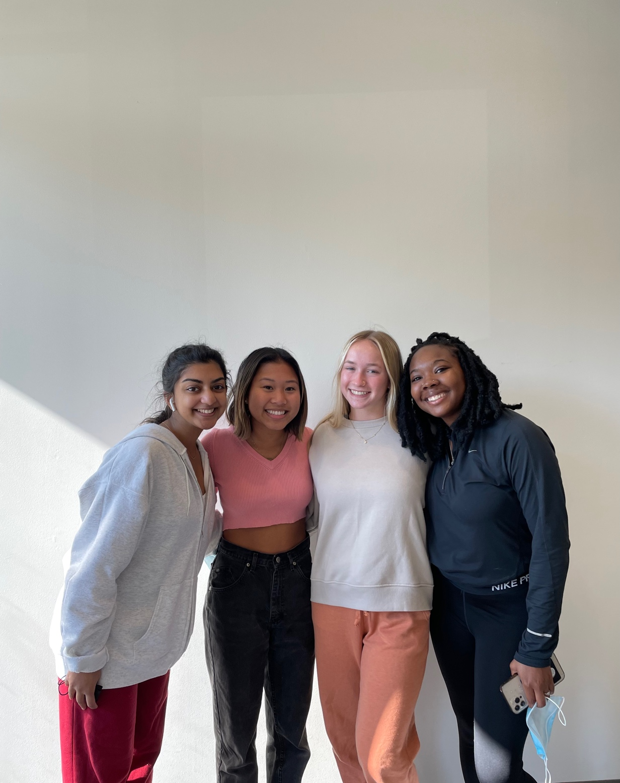

**Left to right - Ria Rajan, Trami Nguyen, Brooke Miller, Dajanae Brangman**